Name: ___________________
SMALL ENGINES
Precision Measurement Assessment

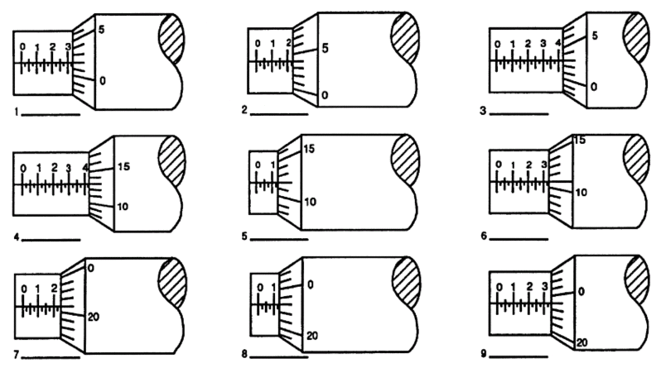

8. Write the measurement of the dial caliper on the line, to the nearest thousandths of an inch.

_________________________
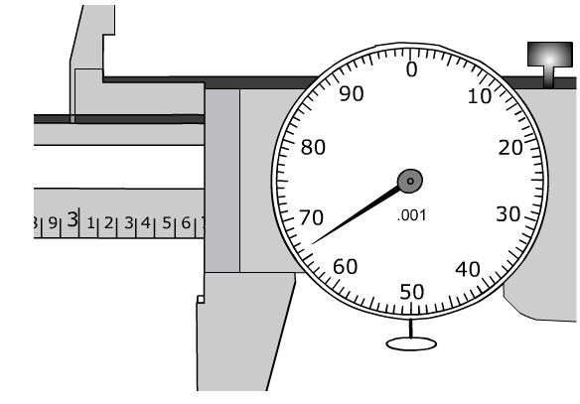
9. Write the measurement of the dial caliper on the line, to the nearest thousandths of an inch.

_________________________

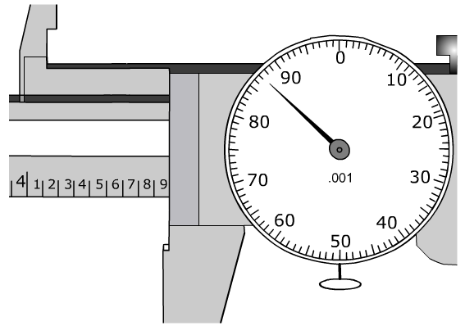
10. Write the measurement of the dial caliper on the line, to the nearest thousandths of an inch.

_________________________

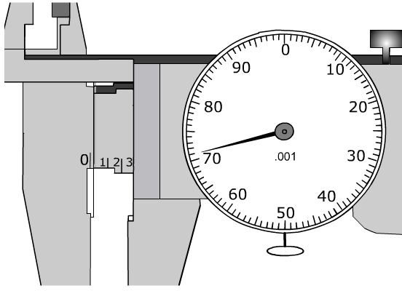
11. Measure the object found in the front of the room by using the dial caliper provided. Write the answer to the nearest thousandths of an inch. (.00).

Object Measurement:____________________________

