Greenhand FFA Degree Requirements
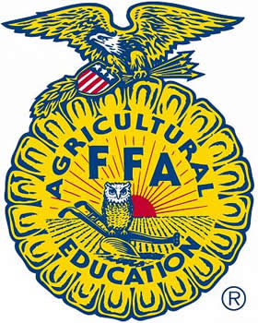
(For 1st Year High School FFA Members)
Please have completed by April 1st in order to be recognized at FFA Banquet.
REQUIREMENT | CIRCLE YES OR NO | STUDENT SIGNATURE | INSTRUCTOR SIGNATURE
Enrolled in at least 1 agricultural education class while in high school?  List Class:_______________________ | YES / NO
FFA Dues paid for Current Year? | YES / NO
Describe SAE Project Area | YES / NO
Can explain meaning of the FFA Creed | YES / NO
Can Explain the meaning of the FFA emblem & colors | YES / NO
Can recite the FFA Motto | YES / NO
Can explain meaning the FFA mission statement | YES / NO
Can demonstrate the proper use of the FFA Jacket | YES / NO

____________________________________ _________________
STUDENT SIGNATURE DATE

____________________________________ _________________
INSTRUCTOR SIGNATURE DATE

