Chapter FFA Degree Requirements
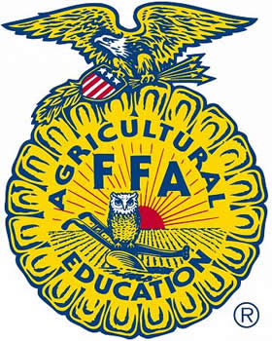
(For High School FFA Members who have already received their Greenhand Degree)

Please have completed by April 1st in order to be recognized at FFA Banquet.
REQUIREMENT | CIRCLE YES OR NO | STUDENT SIGNATURE | INSTRUCTOR SIGNATURE
I have received the Greenhand Degree. | YES / NO
Enrolled in at least 2 agricultural education class while in high school? | YES / NO
FFA Dues paid for Current Year? | YES / NO
Describe SAE Project (On back of form.) | YES / NO
Can explain meaning of the FFA Creed | YES / NO
Can Explain the meaning of the FFA emblem & colors | YES / NO
Can recite the FFA Motto | YES / NO
Can demonstrate the proper use of the FFA Jacket | YES / NO
I have participated in three FFA Activities this year- (list activities on back of form.) | YES / NO
I have led a group discussion in class, or given a speech. (List activity on back of this form.) | YES / NO

____________________________________ _________________
STUDENT SIGNATURE DATE
____________________________________ _________________
INSTRUCTOR SIGNATURE DATE

