Name: _________________________

Plant Science Plant Anatomy, Physiology & Biology

Step 1: Flower Anatomy: View the animation.
http://www.harcourtschool.com/activity/science_up_close/515/deploy/interface.html
Label the parts of the flower
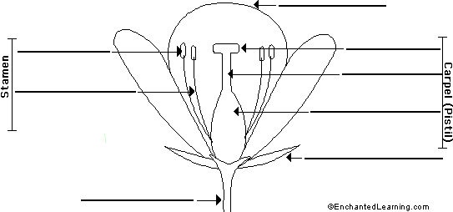

Step 2: Roots
Directions: Next, go to the following site: http://www.harcourtschool.com/activity/root/rootfac.html
Directions: Determine whether the roots are fibrous or tap roots, and either edible or non-edible.

Step 3: Vascular System
Go to the following site and view the animation.
http://www.harcourtschool.com/activity/vascular/vascular.html
List 2 facts about vascular plants:
1). _________________________________________________
2). _________________________________________________

Step 4: Photosynthesis
http://www.harcourtschool.com/activity/science_up_close/512/deploy/interface.html

After viewing the animation, describe 3 things that plants need for photosynthesis.
1). _________________________________________________
2). _________________________________________________
3). _________________________________________________

